VAUXHALL CLUB EVENTS 2025
PAST EVENTS
SUNDAY 17th AUGUST – EASTERN CREEK - 50th DISPLAY

UPCOMING EVENTS
SUNDAY 19th OCTOBER - RUN & PICNIC LUNCH TO MINAMURRA FALLS IN THE ILLAWARRA
Meeting time: 8:45am – Leaving Time: 9:00am
Meeting Location: Uncle Leo’s Roadhouse
Address: 1 Campbelltown Road, Glenfield
Access Charge: $12 per vehicle for the Rainforest Centre
What to Bring: Morning Tea, Lunch, walking shoes. Bring a chair
RSVP: Helen Sara by Friday 17th October
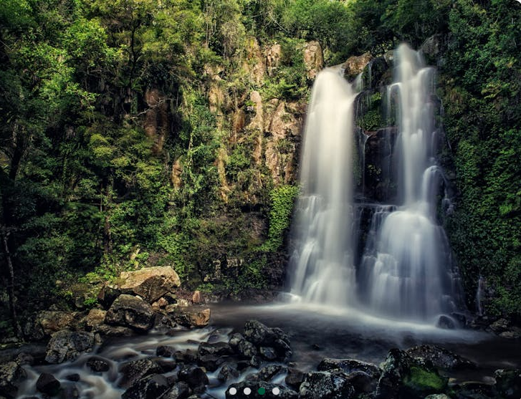
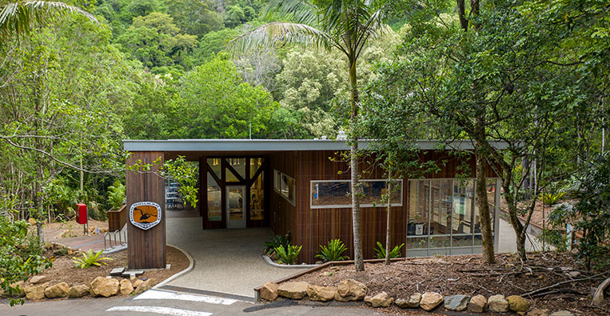
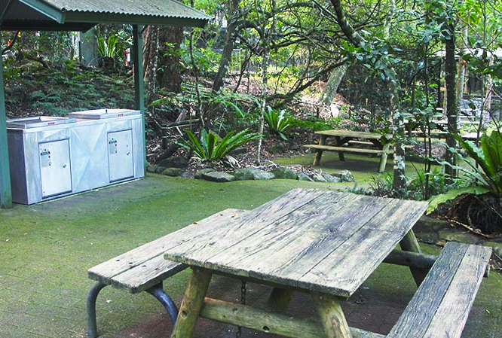

Christmas Weekend Away
Aspen Holidays Koala Shores – Lemon Tree Passage Friday 5 Dec- Sun 7th Dec
Activities
• Friday Night Dinner 6:00pm: Dinner at Club Lemon Tree – Shuttle Bus is available
• Christmas Lunch will be held on Saturday.
• Santa & his elf will make a special appearance.
• On Sunday morning the club will be providing a FREE breakfast.
• Activities available include Fishing/ kayaking/swimming local Board Walks. etc
Christmas Lunch will be held on Saturday at approx. 12:00 noon Wear something Christmassy.
Saturday Night Dinner – (not that we will be very hungry) We will make available any remaining food left after lunch (another chance to try that favourite salad) or you can self-cater or have takeaway /dining options available.
Sunday Morning Breakfast – the club will put on a FREE BBQ Breakfast

RSVP REQUIRED: Friday 21st November 2025 to Helen Sara (details below)
With RSVP, please advise the following:
- Number of people attending.
- If you would like to attend the Friday night dinner at Club Lemon Tree - booked from 6:00pm
- The food you would like to bring for Christmas lunch.
- Whether you are attending for the weekend or day (to assist with catering for BBQ breakfast)

